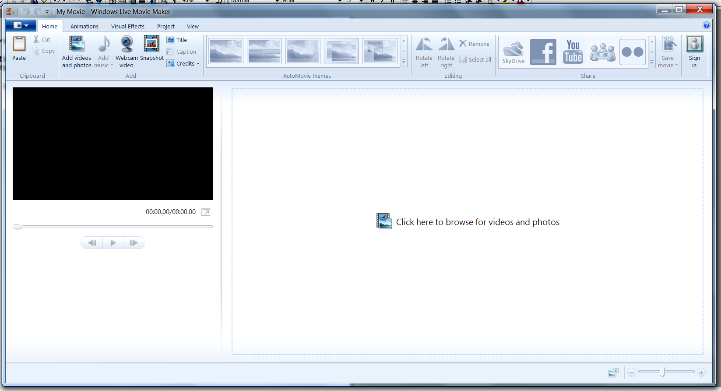With Windows Live Movie Maker
Available in Windows 7, it is either pre-loaded or you can download from the Windows web site.

Additional information
I was asked at the meeting today how to show the timeline, This is NOT available in Live Movie Maker. Which may cause you problems however a fix is available.
If you Google “Movie Maker 2.6” you get to the Microsoft site where you can download this version, it says on the site that it is for Vista but it does work fine in Windows 7 I have tried it.

When you load Live Movie Maker you get the following working pane.

First job is to join movies together.
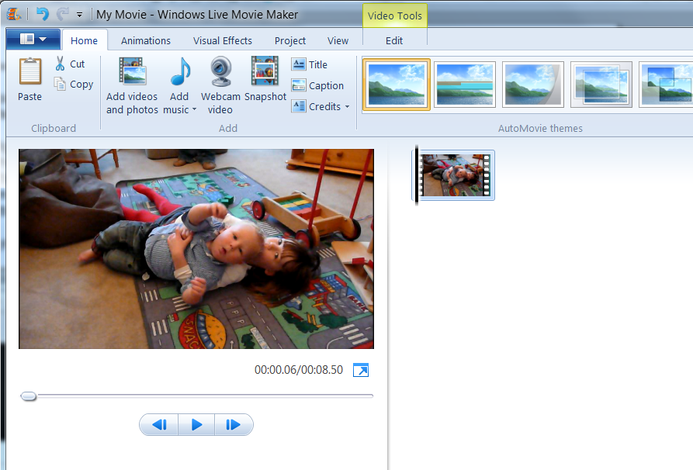
Click <Add videos and photos> browse and add your first movie by dbl clicking it, eg Video Clip 1, when selected you get the following…
Click <Add videos and photos> again and add the second movie you wish to join to the other, and you get the following.
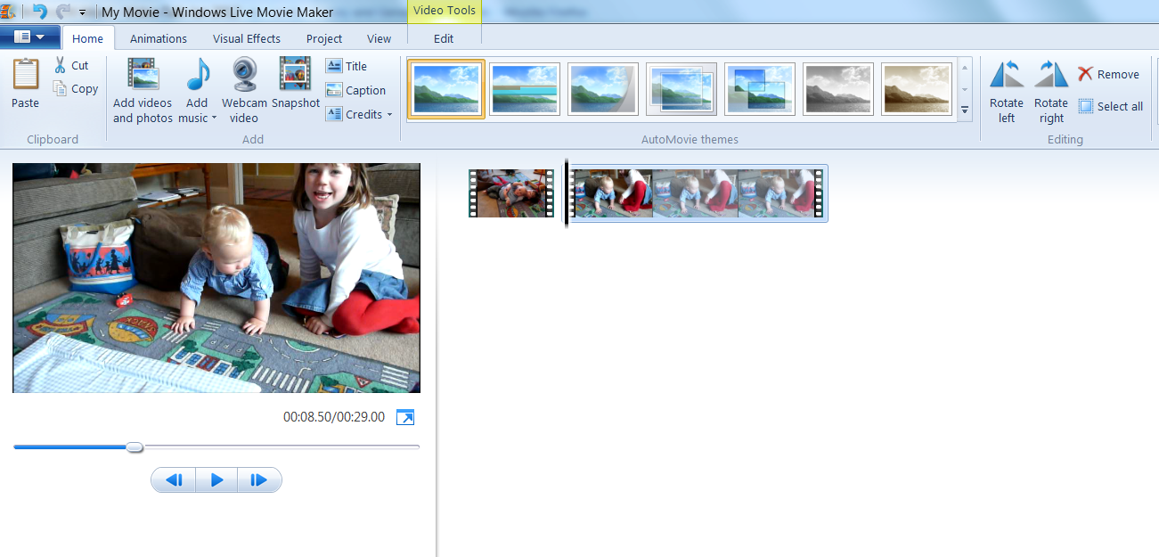
You now have two movies which will play as one continuous one. Carry on selecting more movies until you have all you want. You can drag and drop the movies around to change the order, or right click a movie and remove it if you’ve changed your mind.

Next job put a transition in

To avoid a jump between each movie you can put in a ‘transition’ Click the Animations tab and you get the following

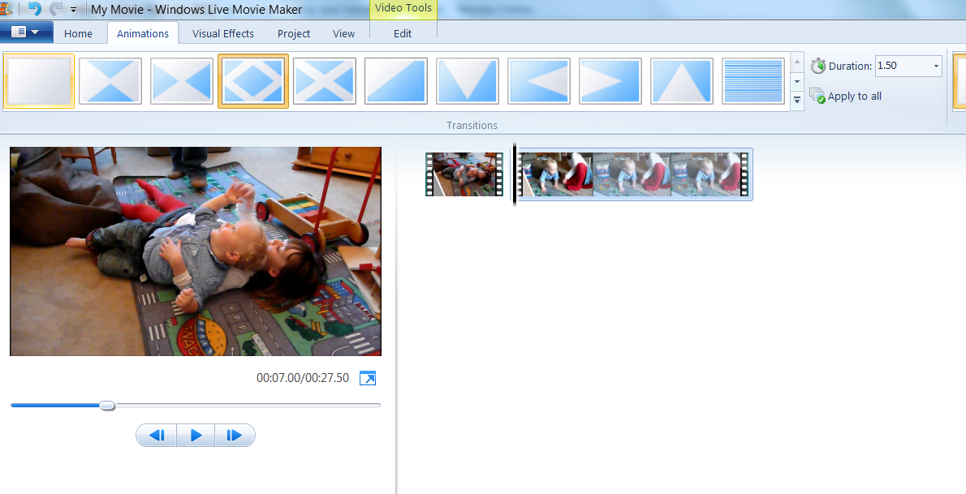
Click one of the choices and it will show you the effect, you can change the length of the transition and or apply it between all the clips if there are more than two.

Next job, removing a bit from the end.

Lets say at the end of one of the movies you’ve accidentally let the camera point down to your feet. You want to remove those few seconds to make it look nice.
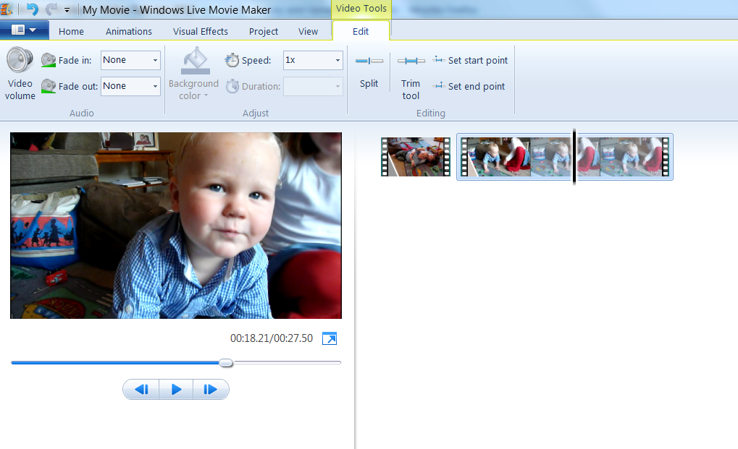
Click the Edit tab and then play the movie until you get to the point where you want it to end, pause at this point. You can move backwards and forwards a frame at a time to get the exact point. You’ll end up with the following.

The black bar indicates the point you are at . Now click “Set end point” and the bit you want removed is chopped off. At no point does editing remove anything the original clips they remain intact.

.
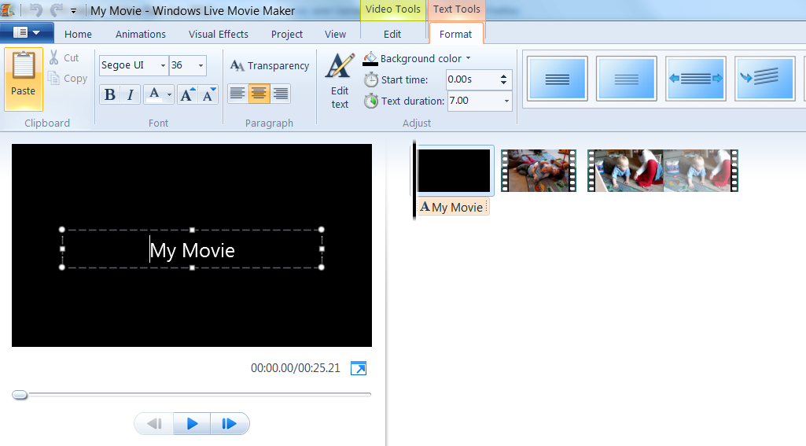
Last job, put a title at the beginning
Make sure the black bar is at the beginning of the movie, click the Home tab and then click Title and you get the following

You can now type in the title you want, you can change the font style, size etc and other things as shown on the toolbar.

Lastly save the movie or burn to a DVD.
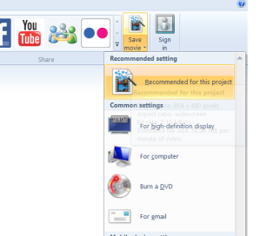
Click the Home tab and then choose from the options found by clicking the down arrow next to ‘Save movie’ on the far right of the toolbar.
If you choose to burn to a DVD, the finished movie is first saved and then the burn DVD window opens thus.
